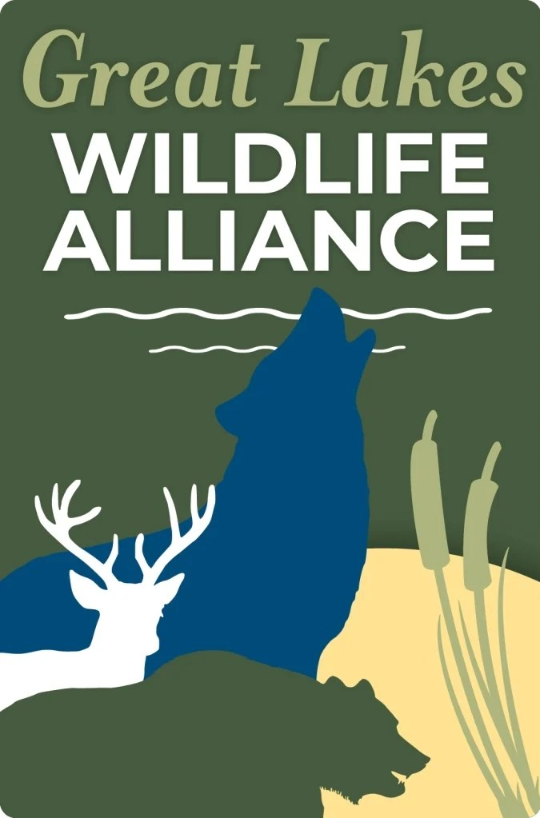
OFFICIAL PUBLIC COMMENT
National Wildlife Refuge System; 2026-2027 Station-Specific Hunting and Sport Fishing Regulations
Docket No. FWS-HQ-NWRS-2026-1223 | 91 FR 31580 | Published May 27, 2026
Comment Deadline: June 26, 2026 at 11:59 PM Eastern
Submitted by: Great Lakes Wildlife Alliance / Friends of the Wisconsin Wolf & Wildlife
117 Ardmore Drive, Madison, WI 53713 | msmith@wiwolvesandwildlife.org | 608-234-8860
Great Lakes Wildlife Alliance (GLWA) submits this comment in strong opposition to the proposed 2026-2027 station-specific hunting and sport fishing rule published at 91 FR 31580. We represent wildlife advocates across Wisconsin, Minnesota, Michigan, Illinois, and Iowa — the heart of the National Wildlife Refuge System's Great Lakes region.
I. This Proposal Violates the Foundational Legal Mandate of the Refuge System
The National Wildlife Refuge System Administration Act, as amended by the National Wildlife Refuge System Improvement Act of 1997, establishes that the mission of the refuge system is the conservation of fish, wildlife, and plant resources and their habitats. Compatible use determinations must be made station by station, grounded in biology, coordinated with state wildlife agencies, and consistent with the purposes for which each refuge was established. A blanket administrative directive opening 95% of the entire system across 111 stations simultaneously is not station-by-station compatibility analysis. It is a political mandate issued from the top down, in direct tension with the statutory framework Congress created.
II. Necedah National Wildlife Refuge and the Whooping Crane Recovery Program Are Directly Threatened
Necedah National Wildlife Refuge in Wisconsin is the primary nesting site for the eastern migratory population of whooping cranes — one of the most endangered birds in North America. Decades of collaborative, multi-million dollar recovery work have been centered at this refuge. Necedah also harbors the world's largest population of endangered Karner blue butterflies, the southernmost wolf habitat in Wisconsin, Blanding's turtles, Eastern massasauga rattlesnakes, and Wisconsin's second largest colony of state-listed endangered black terns.
Documented research shows that at least one in ten whooping crane deaths in the eastern migratory population has been caused by shooting. In early 2026, the Wisconsin Legislature rejected a Sandhill Crane hunting bill in part because of documented whooping crane misidentification risk — including a case in Oklahoma where hunters were convicted of killing endangered whooping cranes. Expanding hunting pressure at Necedah in the immediate aftermath of that legislative defeat is reckless and directly contradicts the scientific findings that drove that rejection.
III. This Proposal Functions as Infrastructure for Habitat Degradation and Eventual Land Disposal
Roads, ATV trails, bait stations, and clearings built to support expanded hunting access do not disappear when seasons close. They permanently alter habitat, fragment movement corridors, and degrade the ecological integrity that makes refuges function as refuges. This administration has simultaneously signaled intent to reduce the federal land estate. Opening refuges to intensive consumptive use degrades their conservation value and creates a pretext for future disposal — lands that have been roaded out and degraded are far easier to justify transferring.
Congress and the public should understand that access expansion and land transfer are connected strategies, not separate policies.
IV. Enforcement Capacity Has Been Gutted at Precisely the Moment Access Is Being Expanded
This administration has cut refuge staff and law enforcement across the system. Poaching is already endemic on public lands — research documents that for roughly every deer killed legally, one is killed illegally. Expanding access without the personnel to manage it or enforce regulations does not serve wildlife or the public. It opens protected areas to exploitation at a moment when the system's capacity to respond has been deliberately diminished. This is not stewardship. It is abandonment.
V. Rescinding Non-Lead Ammunition Requirements Is Scientifically Indefensible
This proposal rescinds previously finalized non-lead ammunition, shot shell, and tackle requirements at nine national wildlife refuges — requirements set to take effect September 1, 2026 following rulemaking processes completed in 2022 and 2023. Lead ammunition has been banned for waterfowl hunting nationally since 1991 because it poisons bald eagles, ravens, and other scavengers that feed on gut piles and carcasses. Rolling back non-toxic requirements on refuge lands exposes eagles and non-target species to lead poisoning in the places specifically designated to be their sanctuary.
The firearm industry, which is celebrating this proposal, has opposed non-lead ammunition requirements at every turn. The inability of that industry to secure even basic toxicological protections for non-target wildlife disqualifies its claim to the conservation mantle.
VI. The Majority of Refuge Users Are Non-Hunters Whose Interests Are Being Subordinated
A 2022 USFWS survey found approximately 96.3 million wildlife watchers in the United States — roughly seven times the number of hunters. Refuge visitors come overwhelmingly to observe, photograph, hike, and experience wildlife undisturbed. Expanding hunting into previously protected areas degrades the experience and safety of the majority of refuge users to benefit a minority whose numbers are declining. Refuges are public lands held in trust for all Americans, not a hunting allocation program managed for a single user group and its affiliated industry.
VII. The Public Interest Standard Has Not Been Met
The Administration Act requires that any use be "otherwise in the public interest." A blanket 95% opening driven by executive order and industry advocacy — with staff cuts that eliminate enforcement, non-lead rollbacks that harm non-target species, and no meaningful station-by-station compatibility analysis — does not meet this standard. It inverts it.
Conclusion
GLWA urges the Service to withdraw this proposed rule in its entirety and return to the station-by-station, science-based, compatibility-driven process that Congress mandated and that the public trust demands.

Respectfully submitted,
Melissa Smith, Executive Director
Great Lakes Wildlife Alliance / Friends of the Wisconsin Wolf & Wildlife
117 Ardmore Drive, Madison, WI 53713
msmith@wiwolvesandwildlife.org | 608-234-8860
speakforwildlife.org

