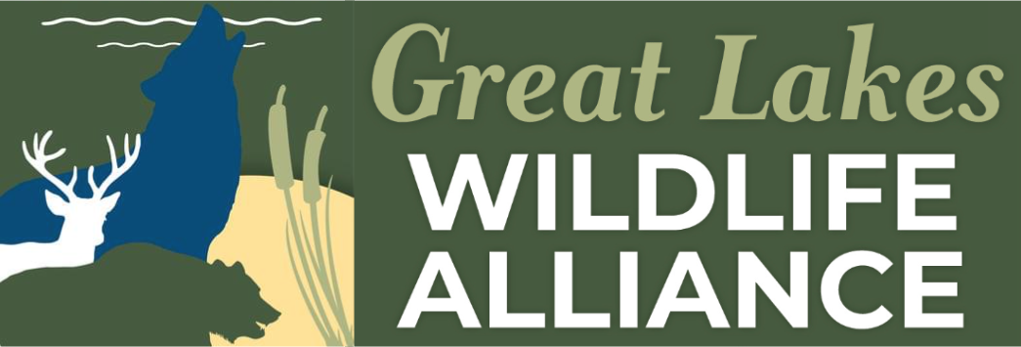

On behalf of over 15,000 wildlife advocates, scientists, farmers, hunters, naturalists, authors, artists, economists, and wildlife watchers, the Great Lakes Wildlife Alliance stands united in its mission to protect biodiversity and uphold the principles of conservation. As a coalition representing diverse voices across the Great Lakes region, we are committed to preserving the ecological integrity of our shared environment for future generations.

Opposition to the Proposed Rescission of the Regulatory Definition of "Harm" Under the ESA

I. Introduction The U.S. Fish and Wildlife Service (FWS) and the National Marine Fisheries Service (NMFS) have proposed rescinding the regulatory definition of "harm" under the Endangered Species Act (ESA), arguing that habitat modification does not align with the statute’s "single, best meaning." However, removing habitat modification from the definition of harm undermines the ESA’s conservation goals, creating scientific, economic, and legal consequences that threaten biodiversity, ecological stability, and long-term economic resilience.

Additionally, this action disregards the voices of Great Lakes Wildlife Alliance advocates across Michigan, Wisconsin, Illinois, Iowa, and Minnesota, who have consistently fought to protect bedrock environmental laws. The public did not vote for the dismantling of fundamental conservation protections, and Congress’s push to eliminate judicial review of such actions threatens democratic accountability.

II. Scientific Argument: The Indispensable Role of Habitat Protection in Species Survival

Habitat destruction is the leading cause of species decline and extinction worldwide. Extensive ecological research confirms that species cannot persist without adequate breeding, feeding, and sheltering conditions. By excluding significant habitat modification from the definition of "harm," the new regulatory framework ignores well-established ecological principles and contradicts decades of conservation science.

Ecological Connectivity & Long-Term Survival: Many endangered species depend on interconnected habitats to migrate, breed, and maintain genetic diversity. Habitat fragmentation disrupts ecological networks, leading to population decline even before direct killing or capture occurs.

Scientific Evidence Supporting Habitat Protection: A 2020 study published in BioScience found that habitat destruction is a primary threat to 2,766 imperiled species in the U.S. The research highlights that species facing multiple threats—including habitat degradation—are at higher risk of extinction.

Wetlands & Great Lakes Conservation: The U.S. Geological Survey (USGS) developed the Great Lakes Coastal Wetland Restoration Assessment, emphasizing the critical role of wetlands in providing habitat for fish and wildlife, improving water quality, and mitigating flooding. Research from The Nature Conservancy highlights invasive species, habitat destruction, and pollution as major threats to Great Lakes ecosystems, reinforcing the need for habitat protections.

Best Available Science on Habitat Destruction: A Royal Society study discusses how biodiversity loss threatens economic and ecological stability. It argues that weakening environmental regulations undermines ecosystem resilience, leading to long-term economic consequences.

Climate Change and Habitat Stressors: Climate change intensifies habitat loss, reducing species’ ability to adapt. The ESA must remain robust to account for cumulative habitat degradation that contributes to species decline.

Ignoring these fundamental ecological principles narrows ESA protections to an impractical threshold, requiring direct evidence of injury or death before action is taken. Such an approach is scientifically flawed and inconsistent with preventative conservation strategies.

III. Economic Argument: The Cost of Species Loss and Weak Conservation Policies

Economic studies demonstrate that environmental degradation leads to financial instability and long-term economic losses. Weakening habitat protections under the ESA carries significant economic risks for industries dependent on healthy ecosystems, including agriculture, fisheries, tourism, and real estate.

Ecosystem Services & Natural Capital: Healthy ecosystems provide essential services valued at trillions of dollars, including pollination, water filtration, and climate regulation. Species loss reduces biodiversity, diminishing these services and increasing costs for industries reliant on natural resources.

Fisheries & Agriculture Disruptions: Many commercially valuable species rely on protected habitats. Weakening habitat protections under ESA will accelerate population declines, leading to reduced fish stocks, agricultural productivity losses, and economic instability in rural communities.

Wetlands & Great Lakes Economic Impact: The Great Lakes region generates billions of dollars annually through fisheries, recreation, and tourism, all of which rely on healthy habitats. Weakening ESA protections could disrupt industries dependent on biodiversity, leading to economic instability across multiple sectors.

IV. Legal Argument: The Misinterpretation of "Take" and the Legislative Intent of the ESA

The proposed rescission misinterprets the ESA’s statutory language and violates foundational legal principles that underpin conservation law.

Legislative Intent & Broad Interpretation: The ESA was enacted to "halt and reverse the trend toward species extinction, whatever the cost." Congressional records indicate a broad definition of "take" that includes indirect actions harming wildlife.

Threat to Democratic Accountability & Judicial Review: Congress is actively pursuing legislation to eliminate judicial review of environmental regulations, further eroding democratic oversight.

V. Conclusion: Protecting the Integrity of the ESA

The rescission of the regulatory definition of “harm” ignores scientific evidence, threatens economic stability, and undermines legal precedent. Habitat destruction is a critical driver of species decline, and excluding it from ESA protections weakens conservation efforts and jeopardizes biodiversity.

Maintaining the existing definition aligns with scientific research, economic sustainability, and legal consistency. Therefore, stakeholders—including scientists, policymakers, and the public—must oppose this regulatory rollback to ensure the ESA continues to protect endangered species as intended.

The economic impacts of the ESA on local communities further underscore its importance. By supporting industries like fishing, tourism, and agriculture, the ESA not only protects biodiversity but also sustains livelihoods and promotes long-term economic stability. Conservation efforts create jobs, enhance property values, and ensure that future generations inherit a thriving natural world. Weakening these protections risks undermining both ecological and economic resilience, making it imperative to uphold the ESA’s foundational principles.

Additional Considerations for Strengthening ESA Protections

To ensure the ESA remains effective in protecting endangered species and their habitats, policymakers should consider the following:

Increased Funding for Conservation Programs: Allocating more resources to habitat restoration, species monitoring, and public education can enhance the effectiveness of ESA initiatives.

Incentives for Private Landowners: Providing tax benefits or grants to landowners who actively participate in conservation efforts can encourage broader support for habitat protection.

Integration of Climate Change Mitigation Strategies: Addressing climate change impacts through targeted conservation measures can help species adapt to changing environmental conditions.

Strengthening International Collaboration: Partnering with global conservation organizations can amplify efforts to protect migratory species and shared ecosystems.

By implementing these strategies, the ESA can continue to serve as a cornerstone of biodiversity conservation, ensuring the preservation of our planet’s natural heritage for generations to come.

Thank you Melissa Smith
Great Lakes Wildlife Alliance
Msmith@wiwolveswildlife.org
608-234-8860

**Endangered Species Act (ESA)**:

Scientific Citations
- **Wilcove, D. S., & Master, L. L. (2005)** – "How Many Endangered Species Are There in the United States?" *Frontiers in Ecology and the Environment*
- **US Geological Survey (2023)** – "Great Lakes Coastal Wetland Restoration Assessment"
- **Royal Society (2021)** – "Biodiversity Loss and Economic Stability"
- **BioScience (2020)** – "Habitat Destruction as the Leading Cause of Species Decline"
- **Nature Conservancy (2024)** – "Protecting Critical Great Lakes Ecosystems"

Economic Citations
- **American Economic Association (2023)** – "Economic Impacts of the Endangered Species Act"
- **National Bureau of Economic Research (2024)** – "The Cost of Habitat Protections: Impacts on Land Markets"
- **US Fish & Wildlife Service (2025)** – "The Economic Benefits of Conservation Under the ESA"
- **US Environmental Protection Agency (2024)** – "Natural Capital and Ecosystem Services Valuation"
- **University of Wisconsin (2023)** – "Economic Contributions of Great Lakes Conservation"
Legal Citations
- **Endangered Species Act of 1973** – *16 U.S.C. § 1531 et seq.*
- **Federal Register (2025)** – "Rescinding the Definition of Harm Under the ESA"
- **Humane Society v. Zinke, No. 15-5041 (D.C. Cir. 2017)** – *Judicial Precedent on ESA Protections*
- **eCFR :: 50 CFR Part 17** – "Regulations for Endangered and Threatened Wildlife and Plants"
- **U.S. Fish & Wildlife Service (2025)** – "Legal Framework for Critical Habitat Designation"

